2024-2025 Action Plan

Katherine Smith Elementary School

Principal: Melinda Daugherty
School Action Plan – Needs Assessment
Needs related to student achievement data
Katherine Smith Elementary is a B rated campus for the 2023-2024 school year. The data utilized for this needs assessment includes NWEA 23-24 and 24-25 BOY scores, STAAR 2023-2024 results, and IRT 2023-2024 scores.
STAAR
While student achievement is not at accomplished levels, Smith is showing scholar growth at the Meets and Masters tiers. This year, we grew from a D to a B rated campus, and our goal is to be an A rated school for the 2024-2025 school year in both achievement and growth.
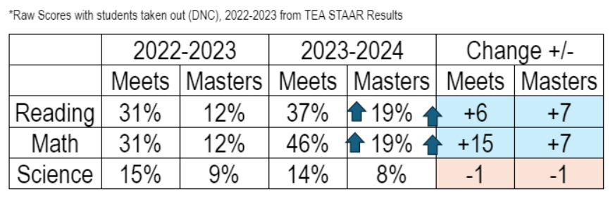
According to our STAAR scores above, we are growing students in the Meets and Masters categories for Reading and Math. In STAAR Science, however, our scores slightly dipped in the Meets and Masters categories and indicate that we must make intentional instructional moves across campus to bolster growth and achievement. Finally, the focus on scaffolding instruction and rigor of written responses aligns with the district goals 1 and 2 for increasing Meets and Masters to 53% in Reading and 53% in Math.
NWEA (2023-2024)
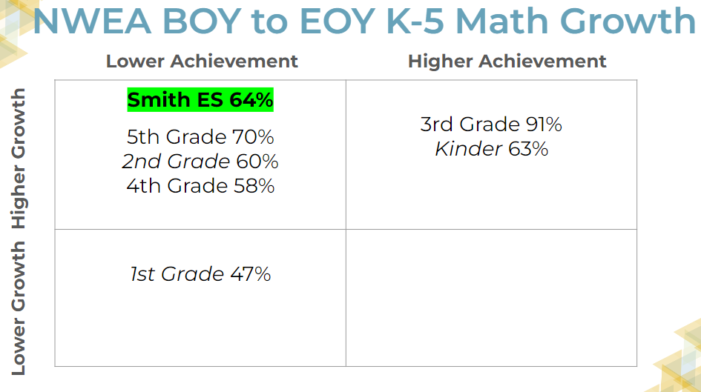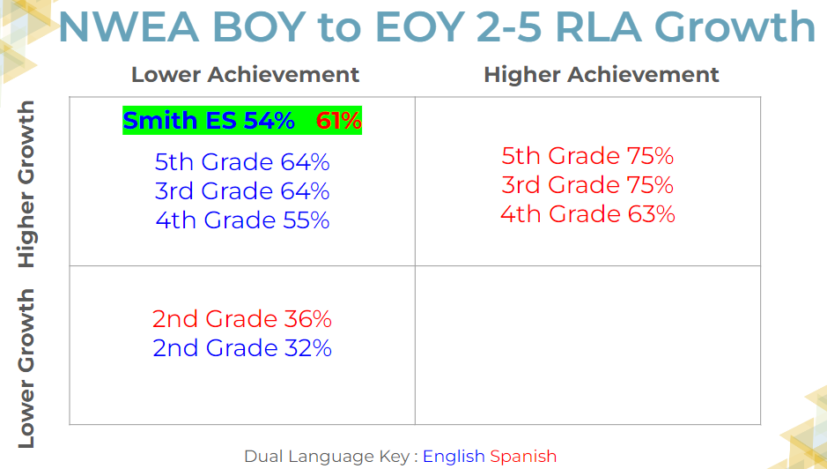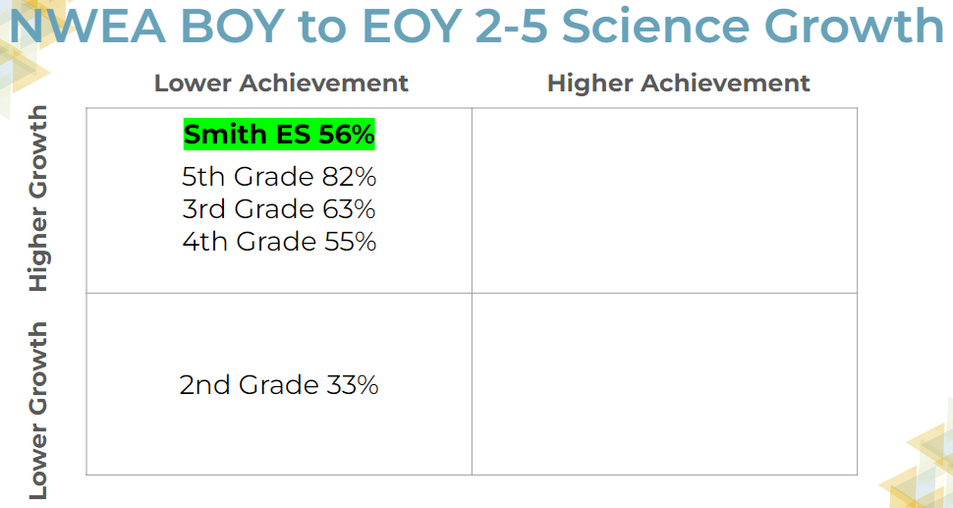

According to our NWEA MAP scores above, we are showing high growth in all content areas, including Science. However, our achievement is still low. When reviewing Mathematics, there are 2 grade levels with high growth and high achievement. In Reading, the data shows a true need to improve sheltered instruction and scaffolding instruction to support our Emergent Bilingual students. As you can see below, in English (blue), 3rd, 4th, and 5th grade were high growth and low achievement, but in Spanish 3rd, 4th, and 5th grade were high growth and high achievement.
Example: NWEA EOY achievement scores in English and Spanish Reading gird a greater need for sheltered instruction. Our English EOY achievement was 22% with 54% growth while Spanish landed at 46% achievement and 61% growth. This data demonstrates that our EB students are capable of learning at higher levels with strong emergent bilingual supports in place.

District philosophy and guiding framework:
Theory of Action
Vision
Core Beliefs

Needs related to student achievement data (continued)
NWEA BOY Achievement Trends
Content | 2023-2024 BOY Achievement Percentile | 2024-2025 BOY- Achievement Percentile
Mathematics | 25% | 32%
Reading | 12% | 15%
Reading, Spanish | 40% | 33%
Science | 15% | 26%

Writing: While students are composing written responses with complete sentences and some evidence, there remains a need to increase complexity and academic vocabulary utilization. The 23-24 STAAR Writing average in grades 3-5 is still below 50%.
Writing Average | 2022-2023 | 2023-2024 | Change +/-
3rd Grade | 30% | 42% | +12
4th Grade | 32% | 37% | +5
5th Grade | 43% | 43% | 0

Our NES campus is utilizing all components of NES and our focus remain aligned with district goals, including a strong first teach using NES curriculum. While our 2023-2024 IRT scores show a 1.21 gain from beginning of year to end of year. Our current goal is to begin at an 11 and work towards a 13. Based on spot data, internalization and customization slides still prove to be a focus, as well as, increasing the focus on scaffolding instruction for Emergent Bilingual and Special Education students. This aligns to HISD district goal 4 for Special Education students.
Teacher Capacity / Quality of Instruction
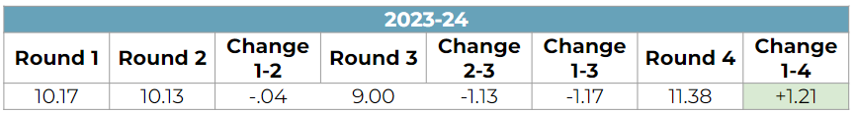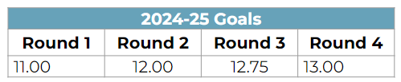

Needs related to improving the quality of instruction
Improve the quality of instruction in Reading, Mathematics, and Science.
Improve the instructional planning process with a focus on scaffolding and student at bats/practice.
Improve sheltered instruction practices within the 1st teach and during the 2nd teach.
Based on the SWOT Analysis with SDMC, Community Meetings, and Faculty meeting, the following were identified as additional instructional needs:
More tutorial days (parent requests for Saturdays and after school)
- Increase in the complexity of student discourse and writing
- Increase rigor of writing in all content areas (Math and Science, as well)
- Increase in teacher and student use of academic vocabulary
- Need for more sheltered instruction strategies
System evaluation (philosophy, processes, implementation, capacity)
- Increase the instructional capacity of teachers to deliver sheltered instruction to EB students
- Increase the instructional capacity to deliver high quality 1st teach with multiple opportunities to check for understanding and practice via student at bats.
- Grow capacity of tier 2 leaders to provide high quality feedback and on the spot coaching.
- Implement effective planning times to support teachers with internalization and customization of slide decks to appropriately target needed supports (differentiation / scaffolding for EBs)

Key Actions
- Increase the rigor of student written responses using academic vocabulary, complete sentences, and the RACE strategy.
- Improve the quality of scaffolding and student at bats within instruction and checking for understanding throughout the first and second teach.
- Campus improves English proficiency for Emergent Bilingual students.
- The principal will ensure IEPs are written effectively, staff are provided relevant portions of the IEP, and accommodations/modifications are documented in PowerSchool.

School Action Plan Template

K  E  Y  A  C  T  I  O  N  O  N  E | Key Action (Briefly state the specific goal or objective.)  KEY ACTION #1  Increase the rigor of student written responses using academic vocabulary, complete sentences, and the RACE strategy.
 | Indicators of success (Measurable results that describe success.)
 | - Indicator #1: 85% of students will consistently score an average of 2 points on a Short-Constructed Response by January 2025 utilizing all components of the RACE strategy. This number will increase to 95% by May 2025.
 | - Indicator #2: By December 2024, 65% of students in grades 3-5 will score a 5 or higher on an Extended Constructed Responses essay. This number will increase to 85% by May 2025.
 | Specific actions – school leaders (What specific action steps will the building leaders take to accomplish the
objective?)

Leadership Actions:
- By the middle of June 2024, leaders will solicit input for a newly generated lesson internalization document that highlights key components of the success for indicators, for teacher leaders to provide input.

- By the end of July, leaders will construct a system, which includes the class process, campuswide schedule, monitoring system, and assessment protocol (schedule) which staff will utilize to facilitate Summit K12. This will include utilization of both TELPAS and other response strategies along with RACE.

- By August Professional Development, leaders will train staff on strategies for campus wide use (academic vocabulary usage, utilization of RACE strategy, highlighting, RACE color coded strategy, annotations).
  - Leaders will create a system for monitoring.
    - Provide data trackers for SCR and ECR
    - Provide feedback to teachers through SPOT coaching/observations and data feedback
    - Each week, leaders will provide campus monitoring and communicate weekly data updates with classroom average scores
    - SCR Tracker by class/campus
    - ECR tracker by class/campus
- By the 3rd week of school, leaders will generate a campus wide grading system for DOL/LSAE written responses to be scored, including a tiered system of incentives for students using the Class DOJO application.

- Progress Monitoring / Data Check In Dates:
September 6, 2024 | September 27, 2024
October 18, 2024 | November 15, 2024
December 13, 2024 | January 13, 2025 MID YEAR REVIEW
February 7, 2025 | February 28, 2025
March 28, 2025 | April 25, 2025
May 16, 2025 | June 4, 2025 END OF YEAR REVIEW

Specific actions – staff (What specific action steps will the staff take to accomplish the objective?)
Teacher / Staff Actions:

- By the end of August Professional Development, teachers will understand how to implement strategies for campus-wide use (academic vocabulary usage, utilization of RACE strategy, highlighting, RACE color-coded strategy, annotations) and will begin to customize lessons to embed them.

- By the first week of school, teachers will implement the monitoring system.
  - Use data trackers for SCR and ECR
  - Provide feedback to students based on data, utilize feedback protocol for both TAPs and LCs.
  - Each week, teachers will provide campus monitoring and communicate weekly data updates with student average scores (Class DOJO incentives)
    - SCR Tracker by class
    - ECR tracker by class
- Track weekly student scores on Short Constructed Responses using the STAAR rubric.
  - Submit weekly scores for SCR & ECR to leaders via tracker.
  - Ensure a SCR is included into each lesson plan.
- Elective class implements SummitK12 lesson cycle with a focus on speaking and writing. To support facilitation, teachers will identify student needs, create groups, and assign specific lessons for Summit.

 | Key Action One:
Staf | Who: All staff
 | What: Increase the rigor of student written responses by students using academic vocabulary, complete sentences with varying structures, and the RACE strategy
 | When: Daily
 | Where: All core classes, and supplemented in Art, Reading, Science, Technology electives
B  u  d  g  e  t | Proposed item | Description | Amount
 | Staff development | RACE, Academic Vocabulary engagement strategies, Sheltered Instruction, Sort It/Pass It writing data PLC protocol, using the STAAR rubric to analyze 5th grade SCR writing samples and their scores
 | Materials/resources | Response cards, updated RACE papers in sheet protectors for all desks in 2-5 classrooms and the Think Tank
 | Purchased services | Pear Deck, Summit K12 (district purchase), Amplify (NES materials-district purchase), | $1400.00
 | Other | Student incentives, Tracking Charts | $8000.00
 | Other | Paper, response cards, pencils, highlighters, supplemental aids, dictionaries
 | TOTAL |  | $9400.00
 | Funding sources: GF1

K  E  Y  A  C  T  I  O  N  T  W  O | Key Action (Briefly state the specific goal or objective.)  KEY ACTION #2  Improve the quality of scaffolding and student at bats within instruction and checking for understanding throughout the first and second teach.
 | Indicators of success (Measurable results that describe success.)
- Indicator #1: By November 2024, 65% of students in grades 3-5 will demonstrate mastery (4 of 5 questions) of the daily DOL in each content area. By May 2025, 80% of students will demonstrate mastery (4 of 5 questions) of the daily DOL in each content area.

- Indicator #2: By November 2024, 75% of teachers will consistently earn the SPOT point for scaffolding and student at bats, and by April 2025, 95% of teachers will consistently earn the SPOT point for scaffolding/student at bats utilizing the campuswide coaching document.
 | Specific actions – school leaders (What specific action steps will the building leaders take to accomplish
the objective?)

Leadership Actions:
- By August Professional Development, leaders will train staff on strategies for scaffolding and higher order thinking question stems.
  - leaders share icon for scaffolding to use in slide decks with examples embedded in first-week lessons during August PD
  - leaders will model student at bats in each content during August PD with a focus on embedding them daily
  - leaders will create and share a platform for shared grade level work such as for monitoring embedded questions for lessons.

- By the 3rd week of school, leaders will begin to provide biweekly data updates with classroom averages scores using DOL tracker data.

- By September, leaders monitor internalization plan and provide feedback to teachers.
  - Leaders will create a utilization plan for reteach and refinement (LSAE time).
- By October 2024 and February 2025, leaders and teacher leaders will lead a data PLC for refinement of unmastered TEKS using NWEA BOY data and Unit Assessment Data.

- Progress Monitoring / Data Check In Dates:
September 6, 2024 | September 27, 2024
October 18, 2024 | November 15, 2024
December 13, 2024 | January 13, 2025 MID YEAR REVIEW
February 7, 2025 | February 28, 2025
March 28, 2025 | April 25, 2025
May 16, 2025 | June 4, 2025 END OF YEAR REVIEW

Specific actions – staff (What specific action steps will the staff take to accomplish the objective?)

Teacher / Staff Actions:
- By the end of August Professional Development, teachers will submit lesson internalization documents weekly to their appraiser that includes scaffolding and higher order thinking questions.
  - Teachers will upload their lessons to a shared learning space weekly
- By the third week of school, teachers will begin to input DOL data on the campus wide tracker.
  - Teachers will keep and utilize anecdotal notes throughout the reteach and intervention.
- By September 2024, teachers will support reteach and refinement plan with team and teacher apprentices.
- By October 2024 and February 2025, 100% of teachers will utilize the NWEA BOY data and unit assessment data to create a refinement plan to support reteaching and refining the non-mastered TEKS.

 | Key Action Two:
Sta. | Who: Teaching Staff
 | What: Scaffold instruction and checking for understanding throughout the first and second teach.
 | When: Daily
 | Where: All core classes, and supplemented in Art, Reading, Science, Technology electives
B  u  d  g  e  t | Proposed item | Description | Amount
 | Staff development | Campuswide internalization plan, use of sheltered instructional strategies, and scaffolding strategies
 | Materials/resources
 | Purchased services | Seidlitz sheltered instruction practices (book previously purchased)
 | Other | Campus internalization documents, PLC trackers,
 | Other | Student incentives for trackers, motivation, attaining goals | $6000.00
 | TOTAL |  | $6000.00
 | Funding sources: GF1

K  E  Y A  C  T  I  O  N  T  H  R  E  E | Key Action: SUPPORTING EMERGENT BILINGUALS  KEY ACTION #3  Campus improves English proficiency for Emergent Bilingual students.
 | Indicators of success (Measurable results that describe success.)
- Indicator #1: By November 2024, 75% of teachers will consistently earn at least 2 points for scaffolding/differentiating in response to EB student misunderstanding within the Campus Coaching Document, and by April 2025, 95% of teachers will consistently earn 2 points.
- Indicator #2: By June 2025, 49% of students who grew one level of proficiency, defined as SY23-24 composite to SY24-25 composite on TELPAS.
- Indicator #3: By June 2025, Smith ES will see a 12% increase in percent of total students who hit the composite score benchmark in DIBELS as compared to EOY SY23-24.
 | Specific actions – school leaders (What specific action steps will the building leaders take to accomplish
the objective?)

Leadership Actions:
- By July 2024, leaders will identify specific sheltered instruction strategies for August PD.
  - This includes identifying campuswide visuals to be posted and used in all classes: TELPAS anchor charts, language supports, word and cognate walls

- By August 2024, leaders will develop and roll out the English Language Development Tracker (ELD) to track student progress throughout reading, writing, speaking, and listening.
  - Leaders will train teachers/staff in implementing the specified sheltered instruction strategies.
  - Leaders will monitor the implemented cognate wall prepped and are ready before school starts.

- By September 15, 2024, leaders will monitor the implementation of Bilingual pairs set up by teachers.
  - By September 2024, leaders and teacher leaders will provide training on Dual Language Preview, View, and Review, Cross-Linguistic Connections, and Total Physical Response training.
- By January 2025, leaders will complete a mid-year review to monitor all classroom elements to support learning for all EBs.

- Progress Monitoring / Data Check In Dates:
September 6, 2024 | September 27, 2024
October 18, 2024 | November 15, 2024
December 13, 2024 | January 13, 2025 MID YEAR REVIEW
February 7, 2025 | February 28, 2025
March 28, 2025 | April 25, 2025
May 16, 2025 | June 4, 2025 END OF YEAR REVIEW

Specific actions – staff (What specific action steps will the staff take to accomplish the objective?)

Teacher / Staff Actions:
- During August Professional Development, teachers/staff will participate in training for Seidlitz strategies, cognate wall, and scaffolding instruction.
  - Teachers/staff will participate in a training for Dual Language Preview, View, and Review, Cross-Linguistic Connections, and Total Physical Response.
  - Teachers will utilize and monitor student goals, including ELD campus tracker.
  - Teachers will post and utilize a cognates wall and campuswide visuals.
- By September 2024, teachers will embed and implement monthly Seidlitz strategies into tier 1 and tier 2 instruction as evidenced by their internalized slides.
  - Within 3 weeks of the 1st day of school, teachers will implement strong Bilingual Pair groupings.

 | Key Action Three:
Staff Devel. | Who: Teaching Staff
 | What: will improve English proficiency for Emergent Bilingual students.
 | When: Daily
 | Where: All core classes, and supplemented in Art, Reading, Science, Technology electives
B  u  d  g  e  t | Proposed item | Description | Amount
 | Staff development | SUMMIT usage, monitoring, and tracking
 | Materials/resources | ELD Assessments, HISD curriculum, campuswide
 | Purchased services
 | Other | printed anchor charts, cognate word walls set up, materials for bilingual pairs
 | TOTAL |  | $0.00
 | Funding sources: GF1
K  E  Y A  C  T  I  O  N  FOU  R | Key Action #4: QUALITY IEPS  KEY ACTION #4  The principal will ensure IEPs are written effectively, staff are provided relevant portions of the IEP, and accommodations/modifications are documented in PowerSchool.
Indicators of Success
- Indicator #1: Throughout the 2024-2025 school year, 100% of staff members receive the relevant portions of the IEP within 3 days of its finalization of the IEP within 3 days of its finalization as demonstrated by campus record keeping.

- Indicator #2: 100% of quarterly audits of Power School records show consistent documentation of accommodations and modifications in PowerSchool.
Specific Actions-School leaders
Leadership Actions:
- leaders will provide training on implementation of accommodations and how to document
- leaders will monitor documentations of accommodations each grading cycle (spot checks)

- Progress Monitoring / Data Check In Dates:
September 6, 2024 | September 27, 2024
October 18, 2024 | November 15, 2024
December 13, 2024 | January 13, 2025 MID YEAR REVIEW
February 7, 2025 | February 28, 2025
March 28, 2025 | April 25, 2025
May 16, 2025 | June 4, 2025 END OF YEAR REVIEW

Specific actions – staff (What specific action steps will the staff take to accomplish the objective?)

Teacher / Staff Actions:
- During August Professional Development, teachers/staff will participate in training for
- Teachers/staff will participate in a training for
- Teachers will utilize and monitor student accommodations, including power school tracker. .
 | Key Action Four
 | Who: Principal, Special Education Department, and teaching staff
 | What: will ensure IEPs are written effectively, staff are provided relevant portions of the IEP, and accommodations/modifications are documented in PowerSchool.
 | When: daily
 | Where: all classrooms that service Special Education students
B  U  D  G  E  T | Proposed item | Description | Amount
 | Staff development | How to utilize and document accommodations. | 0.00
 | Total: |  | $0.00
 | Funding Source:

